**Team ID : C241-PS140**

**Team Member :**

1. (ML) M004D4KY2663 – Mahendra Dwi Karunia Madjid – Institut Teknologi Sepuluh Nopember - [Active]
2. (ML) M114D4KX1961 – Putri Ayu Manurung – Institut Teknologi Del - [Active]
3. (ML) M189D4KX2525 – Rosalia Dina Marina Sipahutar – Universitas Bengkulu- [Active]
4. (CC) C189D4KY0403 – Abram Dimas Hoswandi – Universitas Bengkulu - [Active]
5. (CC) C121D4KY0643 – Rangga Raditya Hariyanto – Telkom Universitas Surabaya- [Active]
6. (MD) A004D4KY4191 – Dylan Kaisar Hasya – Institut Teknologi Sepuluh Nopember- [Active]
7. (MD) A004D4KY3499 – Afanda Mirza Lutfirahman – Institut Teknologi Sepuluh Nopember - [Active]

**Final Selected Themes:**

Sustainable Futures: Nurturing harmony between humanity and the environment

**Title of the Project:**

Recyclopedia: A digital encyclopedia on recycling and waste management.

**Executive Summary/Abstract:**

Dealing with waste problems in Indonesia should begin with educating people about waste management from an early age. According to the Ministry of Environment and Forestry in 2023, there are 5,847,822.52 (tons/year) of waste that is not managed properly. So this requires follow-up that can reduce waste that is not managed properly. Based on these problems, what is an effective way for the community to participate in waste management efforts in Indonesia? How to reduce waste production through an educational approach on how to manage waste properly? Therefore, the goal of our project is to create an application that can help people from children to adults to distinguish the types of waste and how to deal with the waste they find. We want to involve the role of technology and society to support the ESG Program. With our innovation, users just need to scan the type of waste found, then the application will display how to recycle it into useful items. After that, every people can practice it and then collect the processed results to our application to get points for processing waste. Therefore, with everyone participating in recycling waste around us, waste can be turned into more useful items to support ESG programs in Indonesia.

**How did your team come up with this project?**

Our team was inspired to develop this project by the pressing issue of waste management. Recognizing the global importance of environmental, social, and governance (ESG) initiatives, we aimed to address the challenges posed by inefficient waste disposal. The Smart Waste Management System Concept supports ESG programs by introducing innovative solutions. One key aspect is the "Edukasi Daur Ulang" application, which educates users on recycling methods for various types of waste. By empowering individuals with knowledge and practical advice on recycling, we aim to encourage sustainable practices and contribute to a cleaner, healthier environment.

**Project Scope & Deliverables:**

Our Smart Waste Management System Concept to Support ESG Programs focuses on raising awareness and enthusiasm within the community through education especially on waste recycling to preserve their environment using advanced technologies. Users are able to dispose of waste efficiently and instantly receive reward points as a reward for good actions to recycling their waste into other useful things. Our system will utilize AI to analyze, sort, and categorize waste, object or image detection to identify types of waste, optimize the waste management process, and give our user a recommendation related to their waste such as another example of inorganic waste besides bottles and how to recycle it. Additionally, the application will serve as an education center for parents to educate their children about types of waste and how to recycle it, while also providing opportunities for hands-on practice and promoting campaigns of sustainability and responsible waste management practices within community/society. By looking at various aspects and researching existing data, we see that there is great potential from the application that our team is making. Why? Because people are considered insensitive and unaware to protect their environment by disposing of garbage in its place. We conducted a survey to identify the pattern of waste and the scattered technological infrastructure, and mapped out a project that aims to develop a smart waste management system utilizing scanning technology to identify types of waste and provide information on how to process it or create crafts from it. This is certainly in line with the government's commitment in realizing Indonesia Go Green and renewable for responsible environmental practices to support ESG (Environmental, Social, and Governance) initiatives.

**Deliverables :**

| **Responsibility** | **Deliverables** | **Task** |
| --- | --- | --- |
| CC | Develop Backend API | Develop API for read and write database |
| Testing API | Testing the API on the app |
| Deployments | Putting API on the Google Cloud Platform |
| MD | Conduct UX Research | Get user insights then transform it into UI/UX design |
| Develop App | Implementing the UI Design into a mobile application |
| Launch Platform | Do testing and deploy the final app |
| ML | Data Acquisition | Researching & Collecting Data |
| Data Preparation | Cleaning & Filtering Data |
| Modeling | * Transfer Learning from Existing Model * Construct Model Architecture |
| Training Model | Optimizing Model Architecture |
| Model Deployment | Deploying Model to App |

**Project Schedule:**

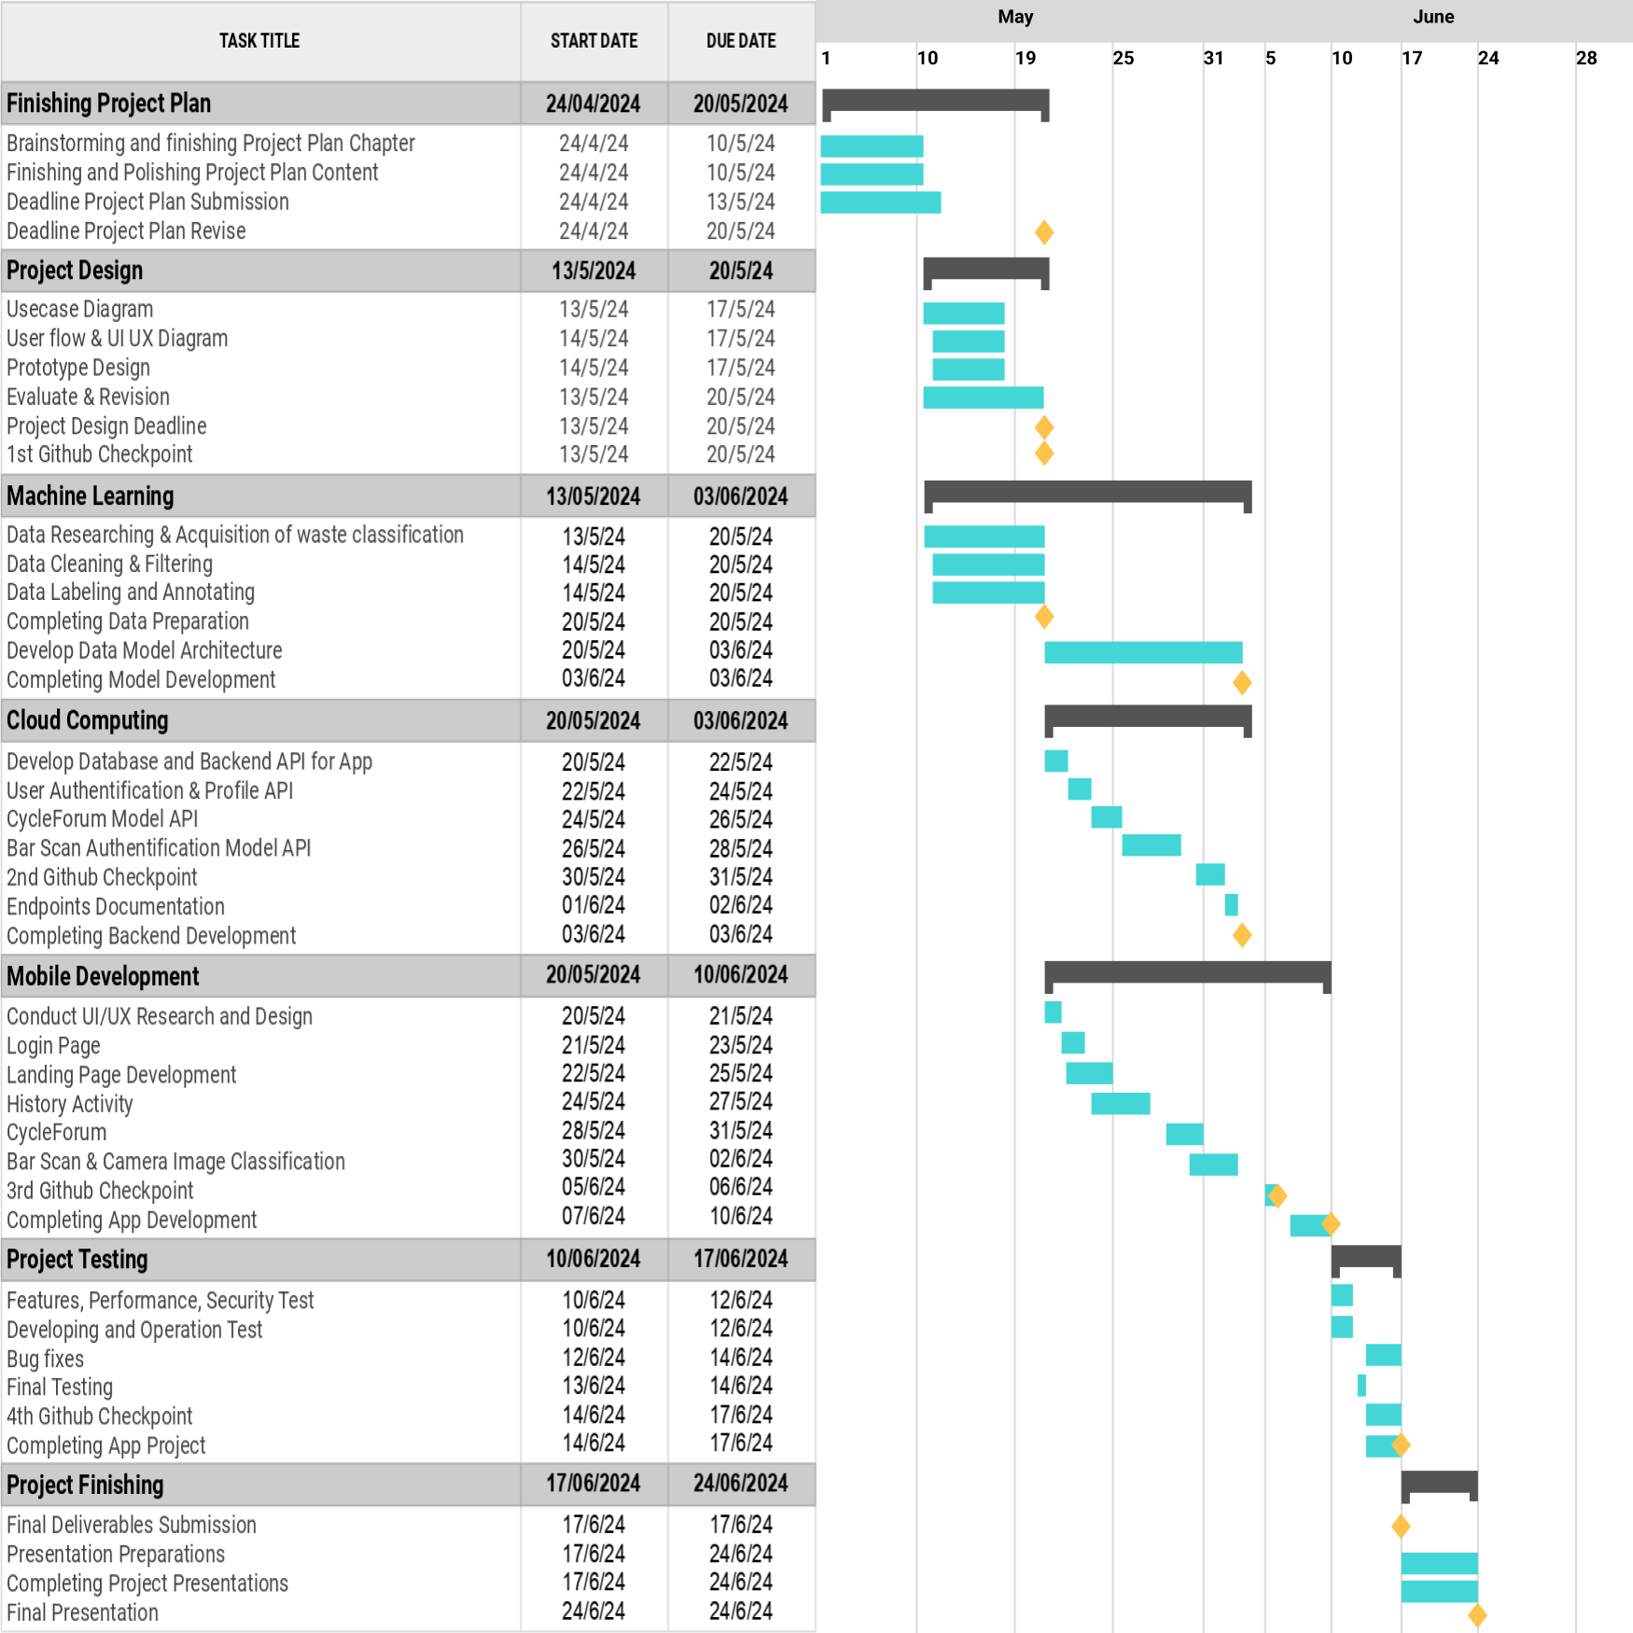

**Based on your team’s knowledge, what tools/IDE/Library and resources that your team will use to solve the problem?**

1. **Machine Learning :**

* Visual Studio Code - Code editor that supports various programming languages and comes with numerous extensions for development, debugging, and project management.
* TensorFlow - Open source library for numerical computation and machine learning, widely used for building and training deep learning models.
* Python Notebook - Is an interactive web application for creating and sharing computational documents.
* Pandas - Open source library providing data structures and data analysis for Python.
* MobilenetV2 - An efficient deep learning model architecture for mobile.
* Numpy - A fundamental library for scientific computing in Python, provides multidimensional arrays and mathematical function.
* Scikit-learn - A machine learning library for Pyhon that provides toools for predictive modelling ncluding classification, regression, clustering, and dimensionality reduction.
* NLTK - NLTK is a library for natural language processing (NLP) in Python.
* Transfer Learning - Transfer learning is a technique where a model trained on one task is reused for another related task.
* Recommendation - Machine learning applications that provide suggestion for a content based on a context that give by user or patterns in data
* TFLite - Other version of TensorFlow for mobile and embedded devices, it enables efficient inference of machine learning models with limited resources.
* YOLO - A real time fast and efficient method for object detection.
* Kaggle - Kaggle is an online platform for the data science and machine learning community.

1. **Mobile Development :**

* Android Studio - Android IDE and Testing Application Code.
* Kotlin - Primary Coding language and to write application logic with cleaner and safer syntax.
* Kotlin Flow - Reactively manage data flows in applications, such as real-time data updates.
* RX Binding - Tools to easily manage UI data changes and automatically based on data changes.
* Android Jetpack Library - Provides Android Primary components such as LiveData, ViewModel, and Navigation to manage application lifecycle and navigation.
* Retrofit - Fetch and send data to the server for features such as waste management status reports.
* Material 3 - Implement aesthetic and functional UI elements according to Material Design standards.
* Jetpack Compos - Create and manage UIs more easily
* Firebase Analytics - Collects data on user behavior for better decision making.
* Firebase Crashlytics - Monitor and analyze crashes to improve app stability.
* Dagger Hilt - Efficiently manage dependencies in applications for better modularity and testing.
* Android Developer Documentation - A reference source for guides, tutorials, and APIs.
* Figma - Design wireframes, mockups, and prototype applications before implementation.

1. **Cloud Computing :**

* Visual Studio Code - to write programming code
* Github - for version control and collaboration
* Hapi - framework for node.js
* Fast API - web framework for building APIs with Python 3.7+
* Firestore - for storing user data
* Docker - platform for developing, shipping, and running applications in containers.
* Google Cloud Platform (GCP) - a suite of cloud computing services

**Based on your knowledge and explorations, what will your team need support for?**

**Mentors:**

* **Google cloud** platform credit to access google platform
* **Machine Learning/Data/AI** (Need Mentoring): model development, data analysis
* **Cloud/Web/Backend/Frontend** (Need Mentoring)
* **Android/Mobile Development** (Need Mentoring)
* **Business/Commerce/Startup** (Good to Have Mentoring on)
* **Project Management** (Good to Have Mentoring on)
* **Ideation/UI & UX** (Good to Have Mentoring on)

**Data:**

* **Waste Data**: Historical data on waste types, as well as other information related to waste, will be used as a basis for training ML models for waste classification and other analysis.

**Based on your knowledge and explorations, tell us the Machine Learning Part of your Capstone!**

Based on our project, object or image detection for validating the image captured by the user when they wish to dispose their waste, by taking a photo of the object, whether it is inorganic waste, is processed and analyzed using TensorFlow. Another component is object counting for point allocation system.

**Based on your knowledge and explorations, tell us the Mobile Development Part of your capstone?**

Our Android app for Smart Waste Management System Concept to Support ESG Programs, is developed using Kotlin or Java in Android Studio. Figma is employed for designing the UI/UX. Additionally, for cross-platform development extending beyond Android, Flutter or React can be utilized.

**Based on your knowledge and explorations, tell us the Cloud/Web/Frontend/Backend Part of your capstone?**

The cloud part for our project, it ensures the application can receive, display, and save waste classification data to Firebase, and redeem points for each collected waste. Then, in addition to designing the database. Then our group also integrates and implements applications that have been made on the Google Cloud Platform using App Engine or Cloud Run and uses Cloud Storage to store the data. As a material for API testing before deployment, of course our group uses Postman as a testing and documentation tool for APIs.

**Based on your team’s planning, is there any identifiable potential Risk or Issue related to your project?**

For our project, the Smart Waste Management System Concept to Support ESG Programs, two identifiable potential risks have been identified. Firstly, there's a risk that the information received by the user may duplicate previous scan results, leading to a potential redundancy in data. Secondly, given that our training data is extensive, there's a concern regarding the accuracy of our system's predictions. These risks highlight the importance of continuously refining our algorithms and ensuring data accuracy to maintain the effectiveness of our waste management solution.

**Any other notes/remarks we should consider on your team’s application**